Your Pupils’ Quest is to discover…
Unit Question: Why is saying thank you important?
Ask pupils these questions at the start of the unit, once at the check point during the unit and again at the conclusion. Write in a different coloured pen each time.  Do this as a whole class or in small groups. Pupils’ initials can be noted next to the answers they have given. |  | Why do people of faith say thank you to God at harvest time?
 |  | What exactly is being celebrated at harvest?
 | 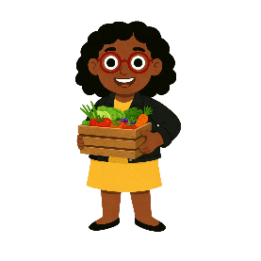 | How do people of faith say thank you to God at harvest time?

 | Godfrey wants to ask these theological questions:  - What does it say in the Bible about celebrating the harvest? | What questions would you like to ask?
 | Phil wants to ask these philosophical questions:  - Why should we help those who do not have a good harvest? | What questions would you like to ask?
 | Sally wants to ask these human social science questions:  - Why do people celebrate harvest festivals?  - How do people of Jewish faith celebrate the harvest?  - How is the harvest celebrated in parts of India? | What questions would you like to ask?

Your Pupils’ Quest is to discover…
Unit 1.1 Question: Why is saying thank you important?
At the conclusion of our Quest pupils decided that the answers to this unit question could include…

